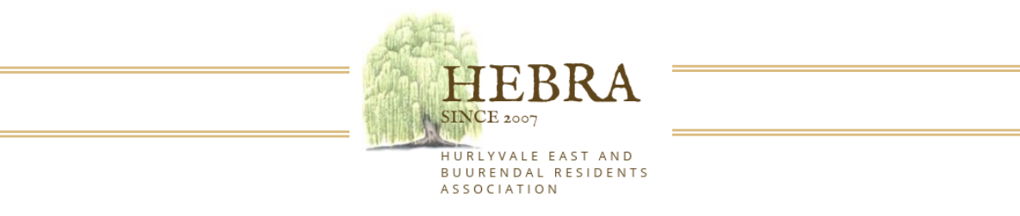

Annual General Meeting: 6th April 2024 Hurlyvale Park at 14H00

ANNUAL GENERAL MEETING (RESIDENTS ONLY)
NOTICE IS HEREBY GIVEN THAT THE HEBRA ANNUAL GENERAL MEETING WILL BE HELD AT HURLYVALE PARK ON SATURDAY 6th APRIL 2024 AT 14H00

You will be able to find the following on our website for download prior to the AGM

- Chairman’s Report
- Financial Reports and Budgets

The Annual General Meeting will be held at the Hurlyvale Park

Yours sincerely,
Hebra Committee

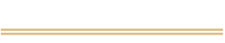
www.hebra.co.za
hebracommunity@gmail.com

