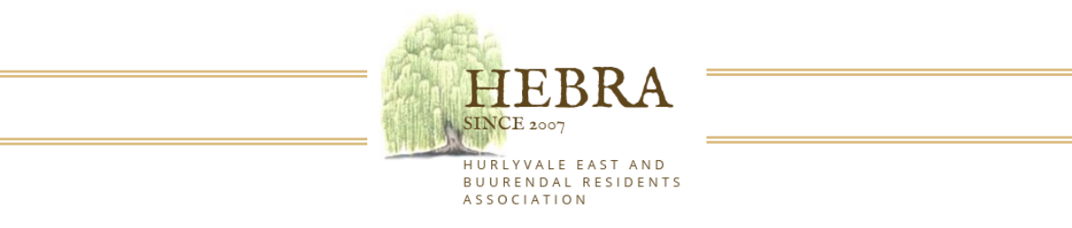

Annual General Meeting: 11th April 2026 Hurlyvale Park at 15H00

ANNUAL GENERAL MEETING (contributing residents only)
NOTICE IS HEREBY GIVEN THAT THE HEBRA ANNUAL GENERAL MEETING WILL BE HELD AT HURLYVALE PARK ON SATURDAY 11th APRIL 2026 AT 15H00

You will be able to find the following on our website for download prior to the AGM

Agenda
- Chairman’s Report
- Financial Reports and Budgets

The Annual General Meeting will be held at the Hurlyvale Park

Yours sincerely,
Hebra Committee

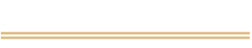
www.hebra.co.za
hebracommunity@gmail.com

